**Top k most frequent elements in the stream**

Problem

Given an array a[] of size n and value k. Our task is to output elements in decreasing frequency till we reach (k+1)th distinct element.

Example:



and k = 2

Output:

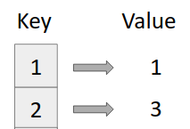

Approach

1. Create a map (say *freq*)

*map<int,int> freq;*

1. While traversing the array keep track of elements and when we find (k+1)th distinct element, break from the loop.
2. Output the element and frequency using map traversal.

Code

